

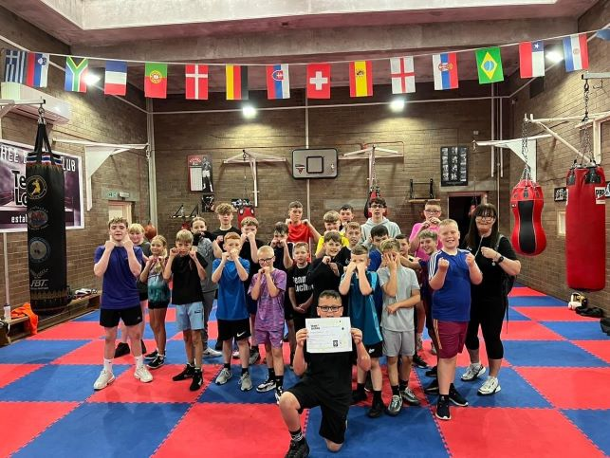

***BOXING SUMMER CAMP***

***Suitable for young people aged 8years to 15 years and extra camps for young people with additional support needs.***

***When Times***

***Wednesday 2nd July 10am to 1pm***

***Thursday 3rd July 10am to 1pm***

***Wednesday 16th July (ASN) 10am to 1pm***

***Thursday 17th July (ASN) 10am to 1pm***

***Wednesday 23rd July 10am to 1pm***

***Thursday 24th July 10am to 1pm***

***Where Price***

***Lochee Boys & Girls Club £5 per day***

***1 Wellbank Lane***

***Lochee***

***Dundee***

***DD2 3FW***

[**https://forms.office.com/r/p7Jw6fthfy**](https://forms.office.com/r/p7Jw6fthfy)

